1. Sanity test

1. Shell info



1. List available shells

1. Hello world bash test using variable

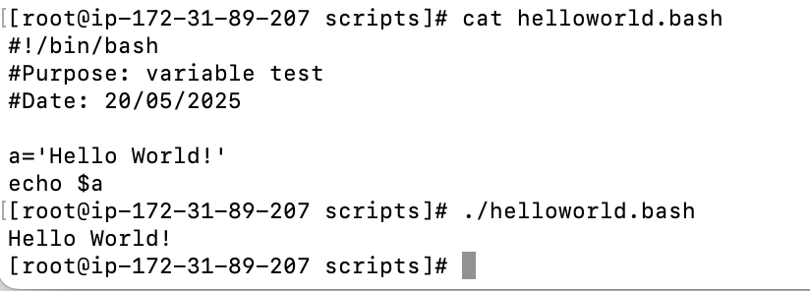

1. Basic admin tasks

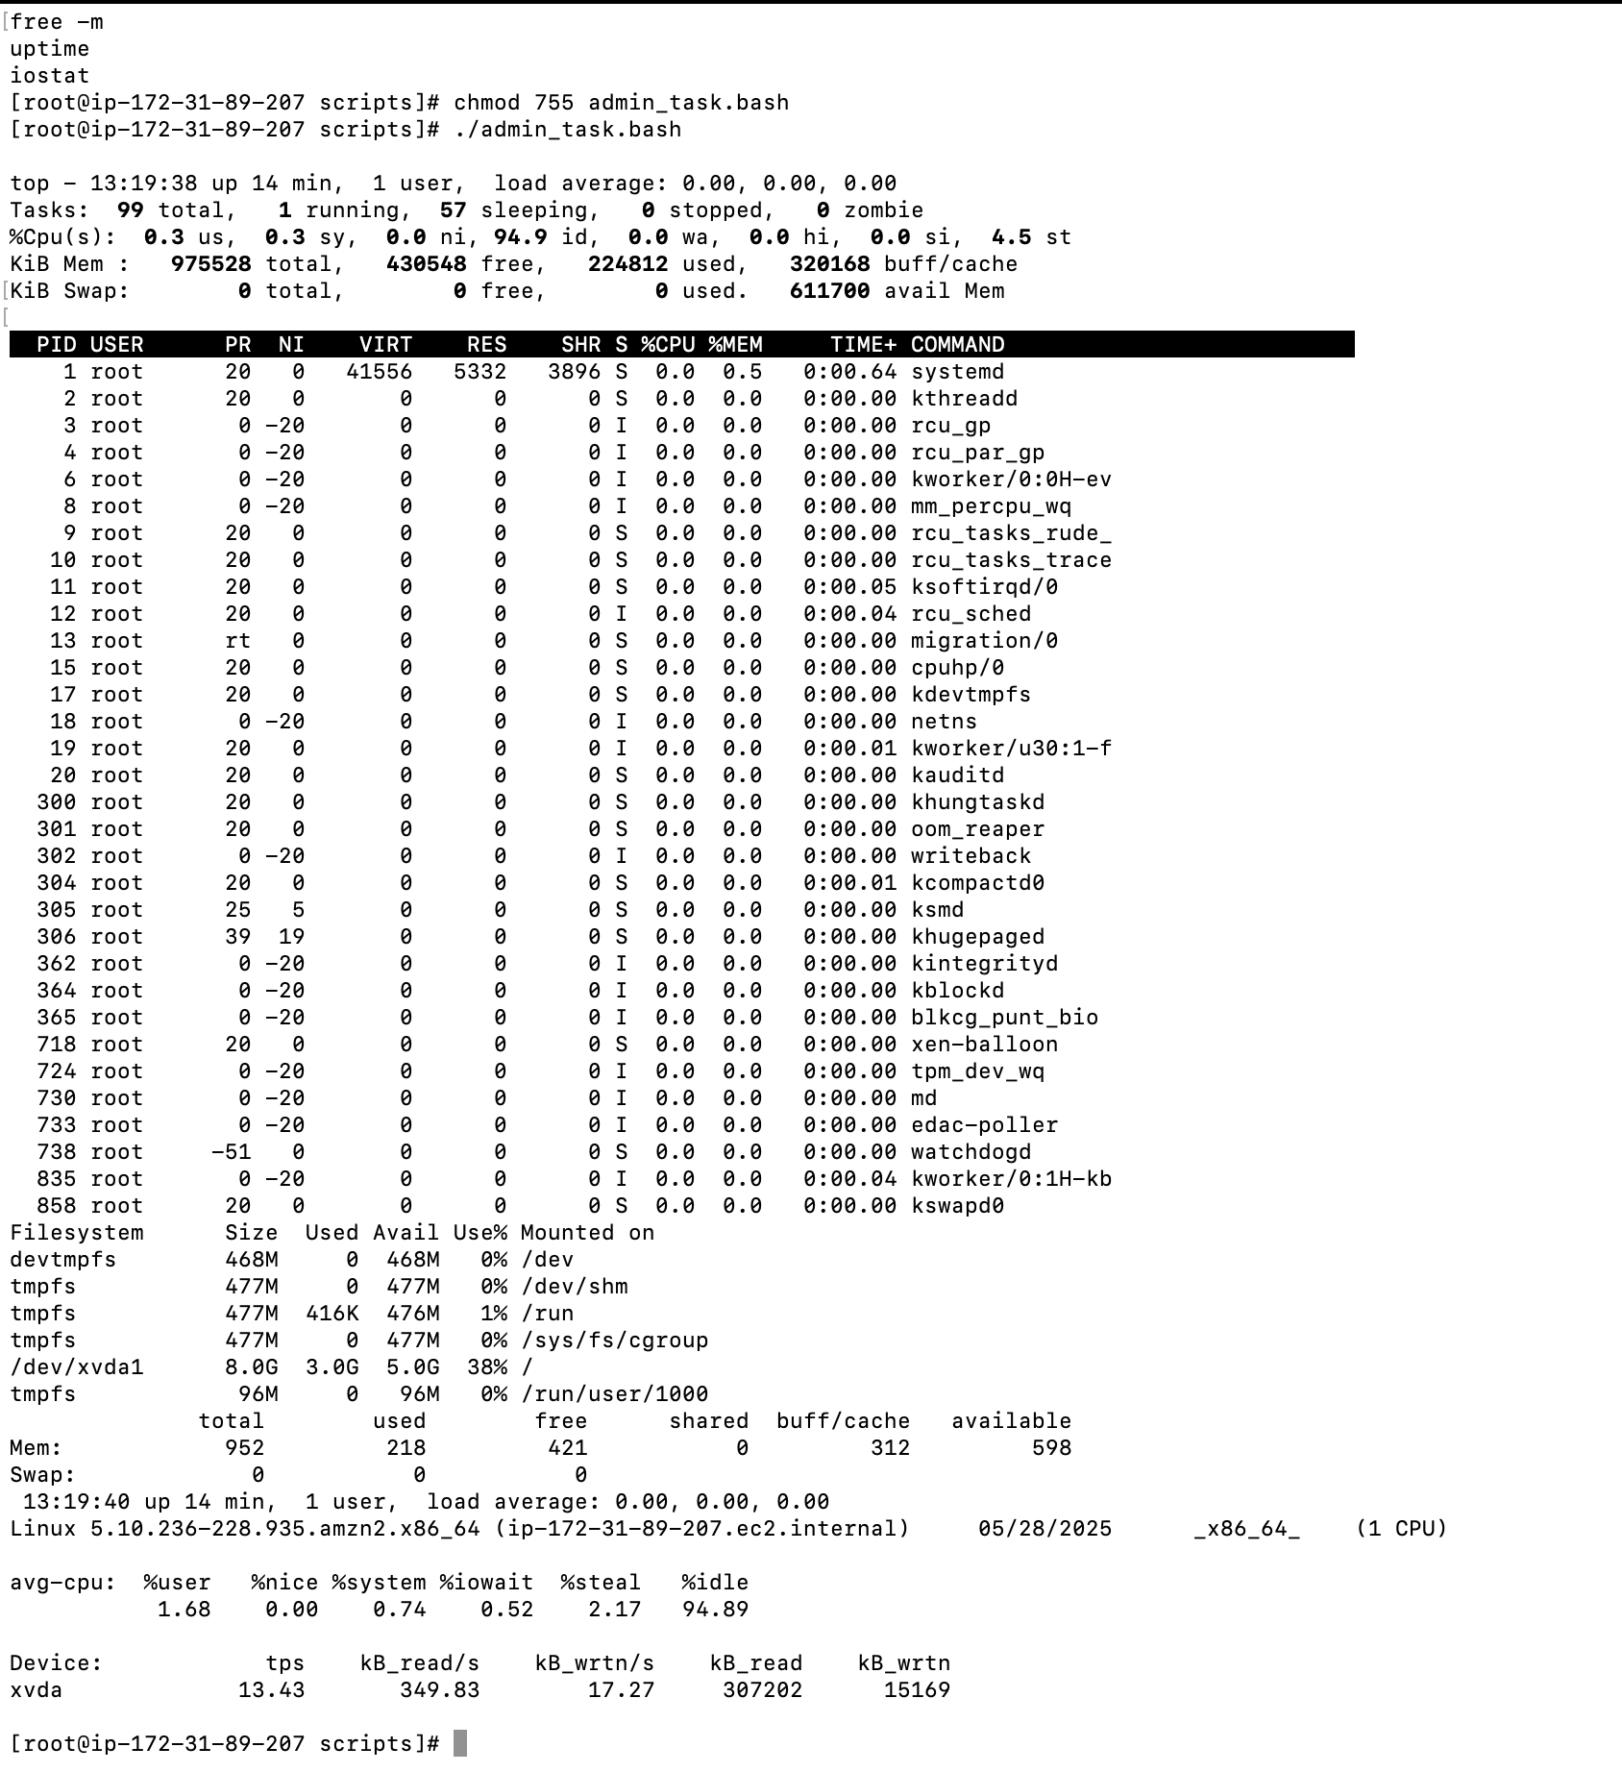

1. Variables task

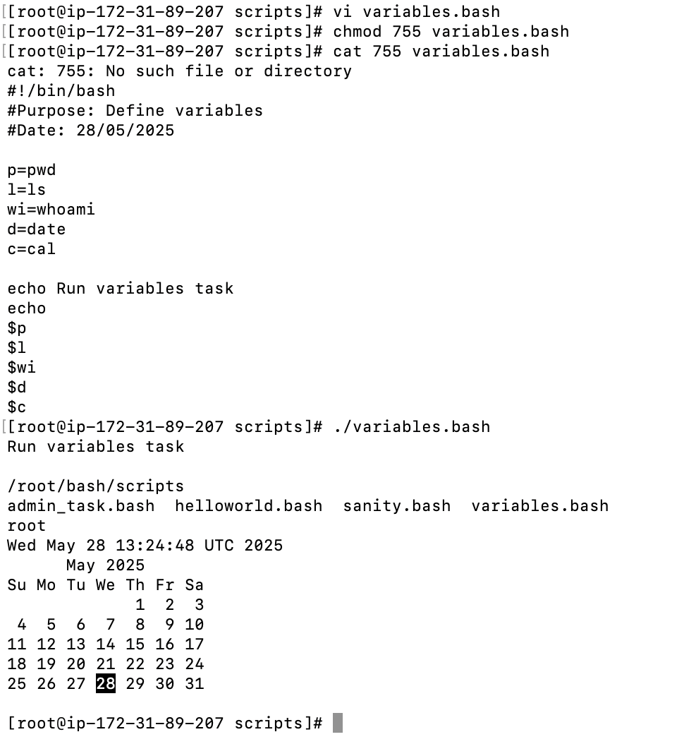

1. I/O Script

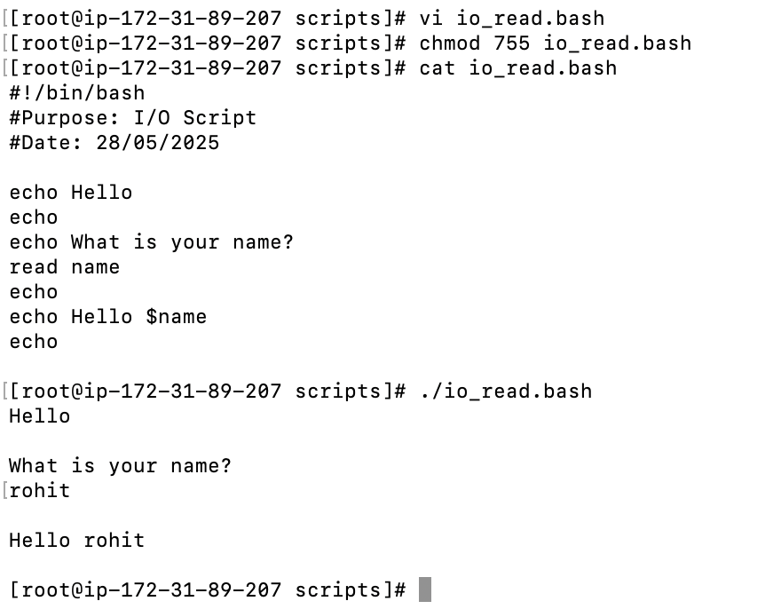

1. Command call in variable

1. If-else statement

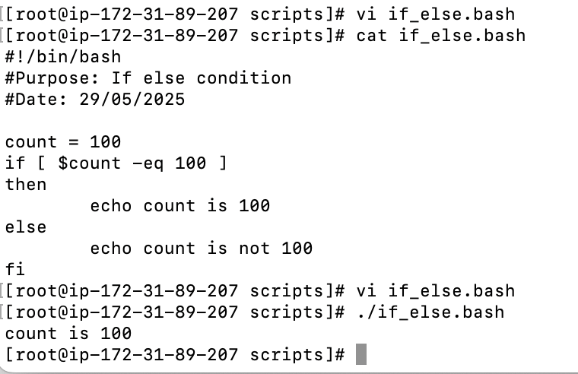

1. write a script to add 2 number

1. write a script to create a directory and check weather its created?

1. write a script using if statement ?

1. write a bash script to create a directory but need to check whether its already there or not if directory not exists then directory has to created ?

1. write a script to find the file in pwd

**If-then scripts:**

1. check if a variable value is met

1. check the response and then output

1. If the output is either Monday or Tuesday

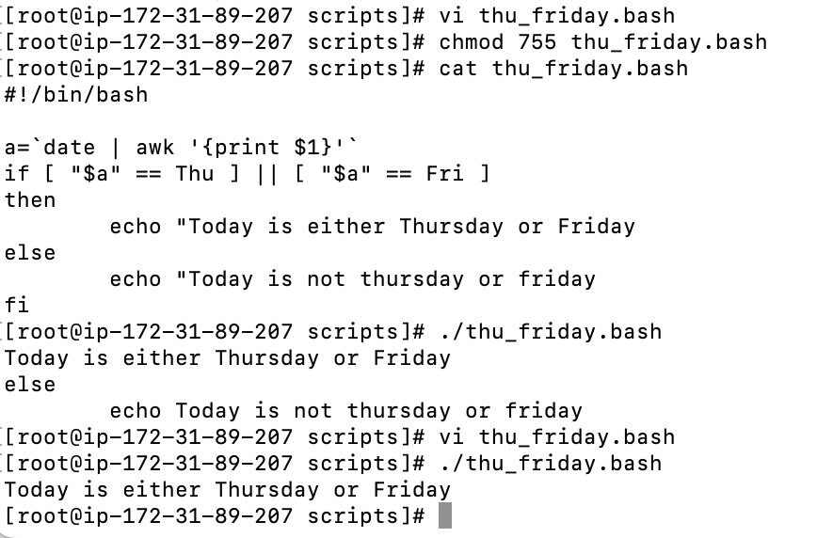

Case Scripts:

1. Select choice

1. Script will look at your current day and tell you the state of backup

For loop scripts:

1. Simple for loop output

1. Simple for loop

1. For loop to create 5 files named 1-5

1. For loop to delete 5 files named 1-5

1. Specify days in for loop

1. List all users one by one from /etc/passwd

Do-while:

1. Script to run for a number of times

1. Script to run number of seconds

Exit:

1. Exit_1

1. Exit_2

1. Return unsuccessful exit status

1. Return exit status if file exists

